- PGDAC Sep22 Batch
- Assignment Submission

Module Name: SDM
Assignment No:01
Group No:029

- Sr. No | - PRN | - Student Name
1 | 220941320019 | Vaibhav borane
2 | 220941320054 | Aniket Kondhekar

1. Create and intialize local git repository having simple angular application with calculator program
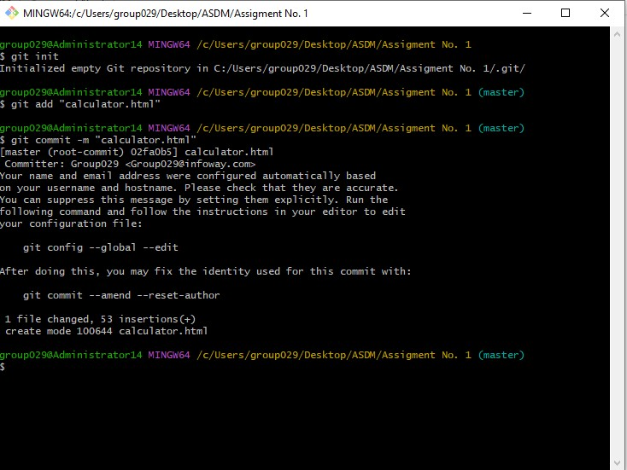
2. Add all the files into the staging area and commit the first draft code .

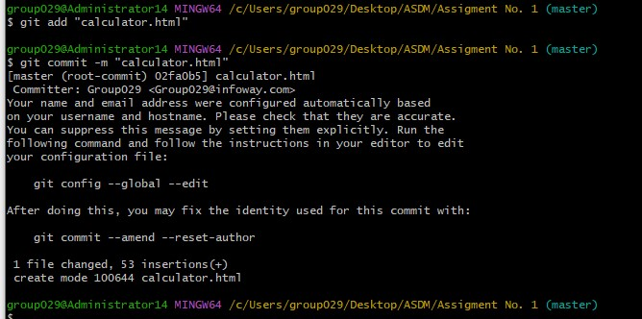
- Update the angular calculator code adding the function to perform percentage operation
4. Add the updated code and create another commit

- Get the log of commits and show the updated files

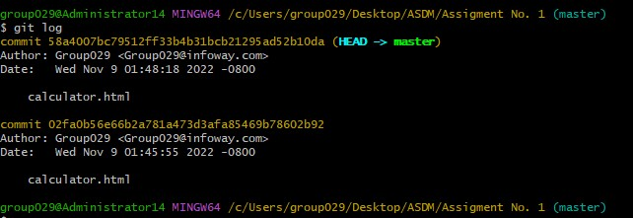
6. Use hard reset to make repository code to initial commit.

7. See the hard commit changed the source code with java calculator application without percentage operation

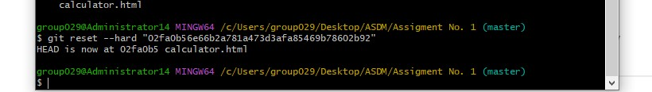

- Create a new branch with the name newfeatures.
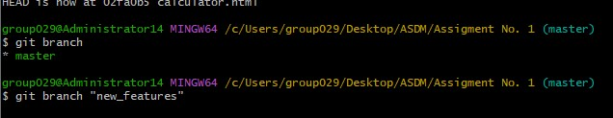
9. Add the new program advance calculator with few advance calculator function and commit it in newfeatures branch.

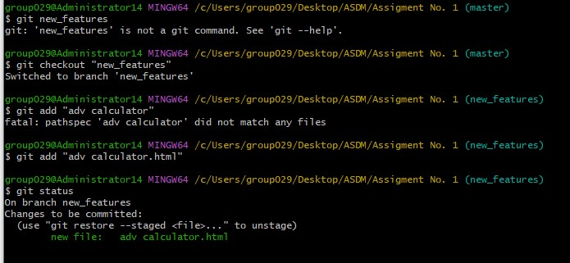

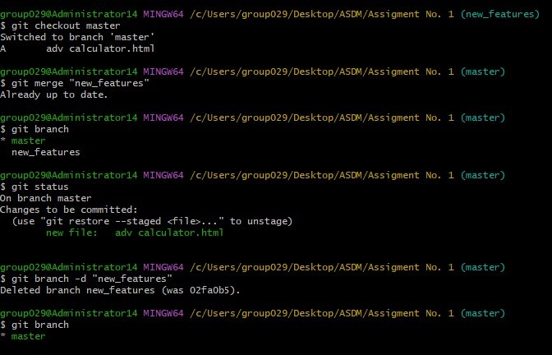
- Merge the branch with master branch
11. Remove the branch newfeatures
12. Commit the code in the master branch
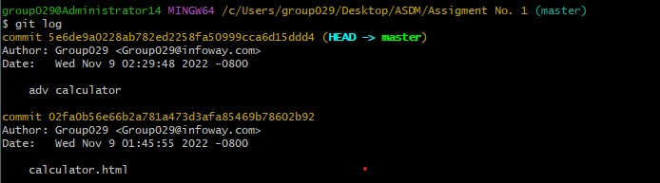

- Create a remote link with your github newly created repository with name calculatorApp

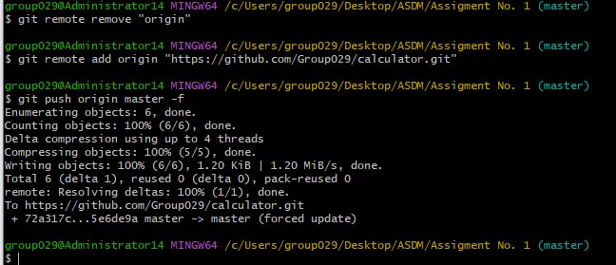
14. Push the changes into your github repository

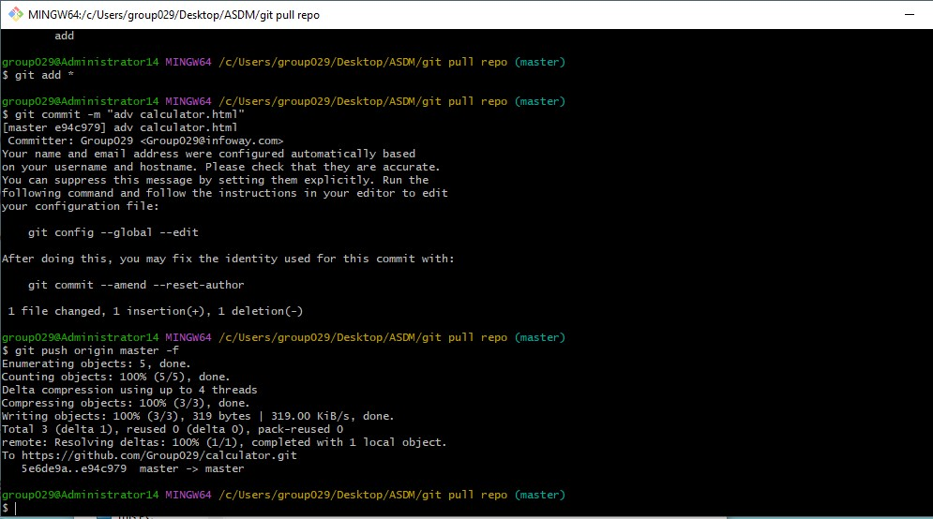

15. Create new folder in your harddrive and use pull command to get your calculatorApp from github repository
16. Make few changes into the code and push it back to the github repository.

